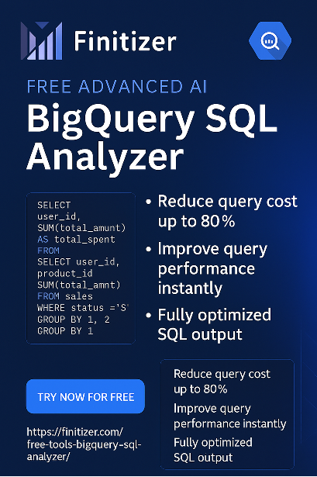

**🔗 Try it now:** [**https://finitizer.com/free-tools-bigquery-sql-analyzer/**](https://finitizer.com/free-tools-bigquery-sql-analyzer/)

**Title**: "**Introducing the Finitizer SQL Analyzer: Smarter BigQuery Cost Optimization Starts Here"**

**Sections**:

* **What is it**
  + **The Finitizer SQL Analyzer** is a free, AI-powered tool designed to optimize your Google BigQuery SQL queries. Using advanced language models, custom prompt engineering, and Retrieval-Augmented Generation (RAG), it analyzes your SQL, identifies costly inefficiencies, and provides actionable suggestions — including fully optimized query rewrites. Whether you're a data engineer, analyst, or FinOps lead, our tool helps you cut costs, boost performance, and follow BigQuery best practices in seconds.
* **Why We Built It**
  + Rising BigQuery costs due to poor query patterns
  + Lack of accessible tools for engineers to self-optimize
* **How It Works**
  + Paste your SQL → AI parses it → Get insights
  + Example: Suggestions on partitioning, data scanned, joins, filters, etc.
* **Real-World Use Cases**
  + FinOps teams monitoring expensive queries
  + Data analysts avoiding SELECT * mistakes
  + Engineering managers enforcing query best practices
* **The Tech Stack Behind the Tool**
  + OpenAI for analysis
  + Built using custom prompt engineering and Retrieval-Augmented Generation (RAG) techniques to deliver precise, context-aware SQL optimization.
* **Try It Today**
  + [Link to the tool](https://finitizer.com/free-tools-bigquery-sql-analyzer/)
  + [Reach out](https://finitizer.com/contact/) to us for any questions, more information or feedback!